
Climate Action Plan
Emmaus Catholic and C of E Primary


1 year plan Autumn 2025 – 2026
Richard.berry@letsgozero.org

Your school’s carbon baseline: 355.35 t CO₂e Calculation: July 2025

Notes: These figures are to be used as an indicative estimation.
Climate Action Plan history
Last reviewed: | 12th May 2026
Progress Key
Not Started
In Progress
Stalled
Complete

= = high carbon reduction actions
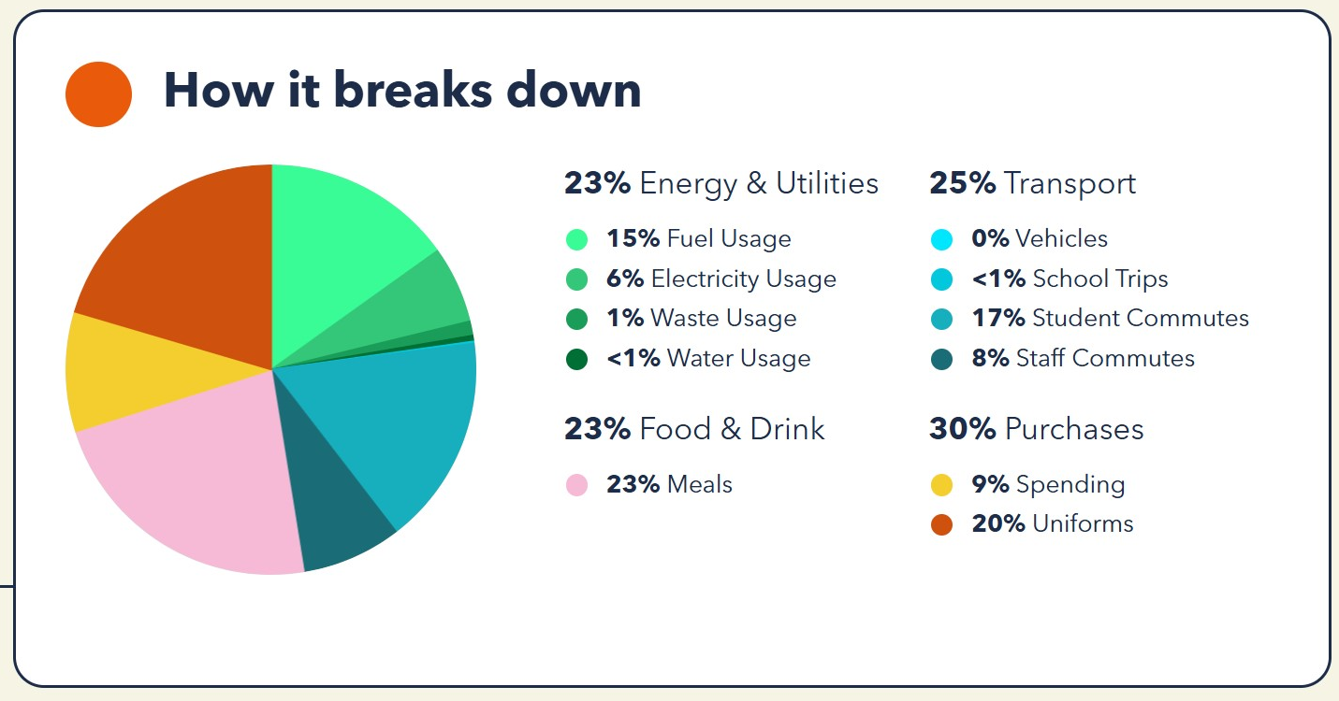

GET STARTED
ACTION | TIMEFRAME | STAKEHOLDERS | NOTES | TRACKER
Sign up to the Let’s Go Zero campaign  By joining this campaign, your school confirms that it is taking action now to reduce its own carbon impact, and that it demands the UK Government help all schools reach this goal by the end of the decade. | Start: July 2025 |  |  | Complete
Calculate your school’s carbon footprint using Count Your Carbon  This free digital tool allows you to calculate the carbon footprint for your educational setting and gives you a baseline against which to measure progress, year on year. | Start: July 2025  Review: July 2026 |  |  | Complete
Add sustainability plans, projects and successes to your school website and share through wider communications  Celebrate your school’s climate action on your website, in newsletters, social media, local press, and events to showcase your successes and involve the wider community. Use the Let's Go Zero comms pack to do this. | Start: October 2025  Review: |  | October 20th: Added a sustainability page to the website and added our carbon footprint and action plan. | In Progress
Set up a sustainability working group  Assemble a Sustainability Working Group featuring different stakeholders across the school to collaborate and effect change. Ensure one person has oversight, taking the title of 'Sustainability Lead' and where possible provide PPA time for this role. | Start: Oct. 2025  Review: |  | Oct. 20th: Sustainability governor, business manager, site manager, assistant head as core working group. | Complete

1. Decarbonisation and Energy Efficiency
Calculating and taking actions to reduce carbon emissions and becoming more energy efficient
ENERGY – BUILDINGS AND RETROFIT
ACTION | TIMEFRAME | STAKEHOLDERS | NOTES | TRACKER
Install a smart meter  Contact your energy and/or water supplier to get a smart meter installed. This is an important first step to get data to track consumption and is needed before you can sign up to energy usage analytics platforms, e.g. Energy Sparks. | Start:  Review:
★ Optimise your BMS/BEMS settings and ensure your heating and hot water systems have efficient timings and temperatures set  18ºC is the general recommendation for classroom temperatures, whilst hot water coming out of taps should be no higher than 43ºC (stored at 60ºC). Experiment with your heating schedule while maintaining comfort - running it one hour less per day or reducing temperatures by 1 degree can cut annual heating costs by 5–10%, according to the DfE. | Start: Sep 2025  Review: | Simon | In progress
Insulate hot water pipes  Insulating bare heating pipes will reduce heat loss by between 50%-70%. | Start:  Review:
Investigate the potential for solar panels  Find out who you need permission from and contact solar providers to check the suitability of your roof spaces and the financial models available (direct purchase, lease, community energy). Aim to compare approaches from at least three different providers to check you are getting options that work well for your setting. Providers we suggest checking with: Solar for Schools & Eden Sustainable. | Start:  Review:
ENERGY – BEHAVIOURAL CHANGE
ACTION | TIMEFRAME | STAKEHOLDERS | NOTES | TRACKER
Take part in a switch off campaign  Take part in a switch off campaign, e.g. Switch Off Fortnight. Aim for 10% reduction of energy use (the typical amount saved by participating schools). Running campaigns before the holiday period (such as a summer switch-down) can lead to reduced energy use over the holiday period. | Start:  Review:
Implement a power down strategy for electrical devices and appliances  Implement power-down strategies across the school, such as sleep and automatic shutdown settings on computers, projectors, and smart boards, and switching off scanners and printers overnight. You can use a mix of automatic (e.g. timer-controlled switches) and manual shutdown approaches depending on need. | Start:  Review:
Ensure staff understand how to heat their rooms in the most energy efficient manner  Give staff clear instructions on how to manage heating in areas they are responsible for, e.g. ensure all teachers know where thermostatic radiator valves (TRVs) are or how to control their classroom thermostat, to turn radiators off before opening windows and how to be proactive rather than reactive to overheating issues. . | Start:  Review:
Monitor energy use on a regular basis through dedicated platforms  Use an energy monitoring platform (e.g. Energy Sparks) to visualise and understand your energy usage. Use the data to look for patterns in day-to-day energy consumption and assess your energy baseload (how much energy you use continually). Armed with this information, you can decide where and when is best to target energy savings. If you are already sending your energy data to your provider, get in touch with them and ask them for access. | Start:  Review:
Ensure your site manager is effectively trained to optimise the BMS/BEMS  Ensure your site manager or caretaker is trained in how to monitor and effectively manage the controls on the school's BMS/BEMS systems. If you are using an energy monitoring system, then staff should be given access to CPD training courses to fully understand this so they can make use of this monitoring data to manage their systems. | Start:  Review:

FOOD
ACTION | TIMEFRAME | STAKEHOLDERS | NOTES | TRACKER
Explain reasons for eating less meat and reducing food waste during lessons, assemblies etc  Promote plant-based menu options. Aim to increase uptake of plant-based meals through pupil-led assemblies. | Start:  Review:
Reduce the quantity of meat in meat-based meals  Explore and implement the addition of meat alternatives into meal-based meals such as lasagnas, bolognese, shepherds and cottage pies etc. Lentils and pulses are excellent substitutes. ProVeg can offer free advice around this. | Start:  Review:

WASTE
ACTION | TIMEFRAME | STAKEHOLDERS | NOTES | TRACKER
Provide students with education on the importance of reducing, reusing and recycling correctly  Teach students about the waste hierarchy: 'Reduce -> Reuse -> Recycle' through a variety of assemblies, workshops and initiatives. These could be run by your eco-team, local authority, or waste contractor. Teach how recyclables are processed and the importance of reducing single-use and supporting a circular economy. Organisations such as Wastebuster, Zone, and Recycle Now have a variety of curriculum-linked resources. Your CAA can provide additional resources on request.E.g.Olio’s back to school declutter | Start:  Review:
Run waste/plastic reduction initiatives or campaigns with pupils and staff  Take school-wide action to reduce waste. Run an initiative yourself, or engage with a local or national campaign. For example, you could work to become a Plastic Free School , with Surfers Against Sewage using their free resources. | Start:  Review:

PROCUREMENT
ACTION | TIMEFRAME | STAKEHOLDERS | NOTES | TRACKER
★ Develop your uniform exchange and extend existing reuse practices.  Evaluate your uniform exchange to track how many items are being re-used, and set a target/take steps to increase its uptake e.g. improved communications to the wider school community and putting systems in place to receive uniform donations from school leavers. Make sure to include PE kit too! | Start:  Review: |  | Oct. 2025: started a termly uniform sale. | In Progress
Develop a Sustainable Procurement policy  A Sustainable Procurement Policy is a document that outlines your school or MAT's commitment to purchasing in a way that is both sustainable and ethical. You can find some further advice and links on creating a sustainable procurement policy here. | Start:  Review:

TRANSPORT
ACTION | TIMEFRAME | STAKEHOLDERS | NOTES | TRACKER
Develop an active travel plan  Create and implement your school travel plan which supports cycling, walking and other forms of sustainable travel. Explore if your local authority offers support for this (ex: contact your travel or road safety officer). Modeshift Stars Education is an accreditation programme you can sign up to whilst creating and implementing your travel plan to track your progress and receive awards. | Start:  Review: |  | Started April 2026- Mrs Mahmood is our Active Travel Lead and we have signed up for Modeshift Stars Education. She has asked staff to fill in surveys with children. | In Progress
Talk to your local authority regarding safety of roads around the school  Talk to your local authority about potential measures to improve road safety around the school. | Start:  Review:
Investigate Installing EV charging points  Discuss with staff at next In-SeT day, the if installing EV chargers would encourage take up of Electric vehicles. (Government grants are available.) | Start:  Review:

2. Climate adaptation and resilience
Taking actions to reduce the risk of flooding and overheating and to future-proof scarce resources for potential shortages

ADAPTATION AND RESILIENCE
ACTION | TIMEFRAME | STAKEHOLDERS | NOTES | TRACKER
Subscribe to receive Heat Health Alerts and write a heatwave policy  Subscribe to the UK Health Security Agency's (UKHSA) Heat-health Alert Service. Familiarise your staff with updated DfE guidance on hot weather. Write a heat wave policy to address issues such as uniform, PE, suncream and outdoor learning. Consider adopting the joint union heatwave protocol including short-term, medium term and long-term measures. | Start:  Review: |  |  | Complete
Have a strategy for planting on site that considers shade and soil stability, and which species are most suitable  Planting within viable locations can provide multiple benefits. Tree or plant species should be carefully selected based upon the location considered. Drought-resistant species or ones that require less watering may be more resilient. The Woodland Trust offers free packs for schools who wish to plant trees onsite. | Start:  Review: |  | Oct. 20th: Had a meeting with Trees 4 Schools, to check our eligibility for a planting scheme with them. | In Progress
Build sheltered areas on playgrounds for heat resilience  Use awnings/shading measures to provide adequate shelter for students on hot days. Review the DfE commissioned ARUP report for schools in London on Adaption and resilience measures for schools for additional retrofit examples and costs to address heat gain on south facing wall. | Start:  Review:

WATER
ACTION | TIMEFRAME | STAKEHOLDERS | NOTES | TRACKER
Raise awareness around water consumption and efficiency  Consider engaging with your local water company who may have an education team or free resources on their websites, from assembly sessions and visits to primary schools for your pupils to webinars, downloadable tools and guides, and more. | Start:  Review:
Install water butts to harvest rainwater  Capture rainwater to use on plants and grounds around school – and help reduce water flow in heavy downpours whilst saving mains water. | Start:  Review:
Install mechanisms to reduce water wastage  At the end of life ensure that taps are replaced by push press mechanisms to reduce water wastage or install low-flow attachments. As and when your existing taps and toilet flushes approach their end of life, ensure that the replacements include flow reduction measures to save as much water as possible, e.g. smaller cisterns or install water hippos to reduce water capacity in normal cisterns. Check your water supplier to see if they do free water audits and installations. | Start:  Review:

3. Biodiversity and Green Infrastructure
Creating habitats and adopting practices that will enhance species diversity on the school estate and beyond

NATURE
ACTION | TIMEFRAME | STAKEHOLDERS | NOTES | TRACKER
Take part in The Nature Park  The Nature Park aims to embed nature-based learning into the curriculum and encourage children and young people all over the country to take action to improve their site for people and wildlife. The programme provides the support and guidance needed to make this happen, with five key steps in the journey and the actions needed to reach your goals. | Start: June 2025  Review: |  | Oct. 20^{th:} Signed up for NENP, and used their resources for our baseline assessments of habitats and species encountered on site for our Fieldwork Fortnight. | Complete
Increase planting of available areas  Identify areas in your school grounds which could accommodate new planting. This could include hedgerows, trees and wildflower meadows or native plants in borders, planters or pots. When planning ensure the "right tree in the right place" principle is followed and consider accessibility and maintenance requirements. Support can be provided by Earth restoration service.  Investigate Learning through landscapes for support with advice and funding. | Start: Sept. 2025  Review: |  | Oct. 20th: Applied for NENP biodiversity, was successful, waiting on funds.  Dec. 1st: Seeds have arrived and a planting programme shared with staff.  May 1st: Some planting has taken place and the ground is being prepared for seed and seedling planting. | In Progress
Further develop work with allotment  Continue to develop the link with the local allotment and ask for support from the RHS on challenging areas to plant. Consider growing initiatives such as GYOP | Start:  Review: |  | Oct. 20th: Signed up for Young Marketeers for a second year.  April 29th: Mr Collis and Mrs Nicholls visited Arbourthorne to look at how they have developed planting and incorporated it into their curriculum.  May 1st: Miss Edghill has started growing with the Young Marketeers. | In Progress
4. Climate Education, Green Skills and Green Careers
Ensuring the education you provide gives knowledge-rich and comprehensive teaching about climate change, and that your teaching staff feel supported to offer this

CULTURE
ACTION | TIMEFRAME | STAKEHOLDERS | NOTES | TRACKER
Sign up to Sustainability Support for Education  A DfE-funded project that enables education settings to start or progress on their sustainability journey. This includes all types of settings from Early Years to Higher Education, offering suggested actions paired with quality-assured resources. You can filter these to show suggestions relevant to your setting based on your teaching age, priorities, how far you’ve progressed already, estate, and more. | Start: September 2025  Review: |  |  | Complete

CURRICULUM
ACTION | TIMEFRAME | STAKEHOLDERS | NOTES | TRACKER
Amend your curriculum to incorporate sustainability  Amend your curriculum to include stronger links to climate change and sustainability. This could be a total refresh, a bit of tweaking, drop down days or simply adding extra assemblies. Teach the Future, Royal Meteorological Society (Curriculum for Climate Literacy) and the MoEE have amazing resources on how to weave sustainability throughout your curriculum. | Start:  Review: |  | Oct. 30th: Held PDM for staff on Citizen Geographers- which incorporates a form of enquiry into geography teaching.  May 1st: Y6 teachers have signed on with Adapt-ed Education: a project with SHU re. their climate change programme. | In Progress
Survey staff on how they feel about teaching sustainability issues  Conduct a survey to understand staff capability to teach sustainability and use this to identify any support needed. This might include asking them to rate their knowledge and confidence about the causes and effects of climate change, as well as the ability to navigate potentially difficult conversations with pupils including eco-anxiety. Let's Go Zero have a template survey you can use. Provide CPD training opportunities for staff on Sustainability e.g Through WWF teacher development. And/or Ministry of Eco education. | Start:  Review:

GREEN SKILLS & CAREERS
ACTION | TIMEFRAME | STAKEHOLDERS | NOTES | TRACKER
Access the Climate Ambassadors scheme  Connect with Climate Ambassadors in your region and invite them to do school assemblies on green skills and curriculum linked topics. | Start:  Review:




www.letsgozero.org

Ashden is registered in England and Wales as a company limited by guarantee.
Registered number: 05062574/ Charity number: 1104153
The Peak, 3rd Floor 5 Wilton Road, London, SW1V 1AP

