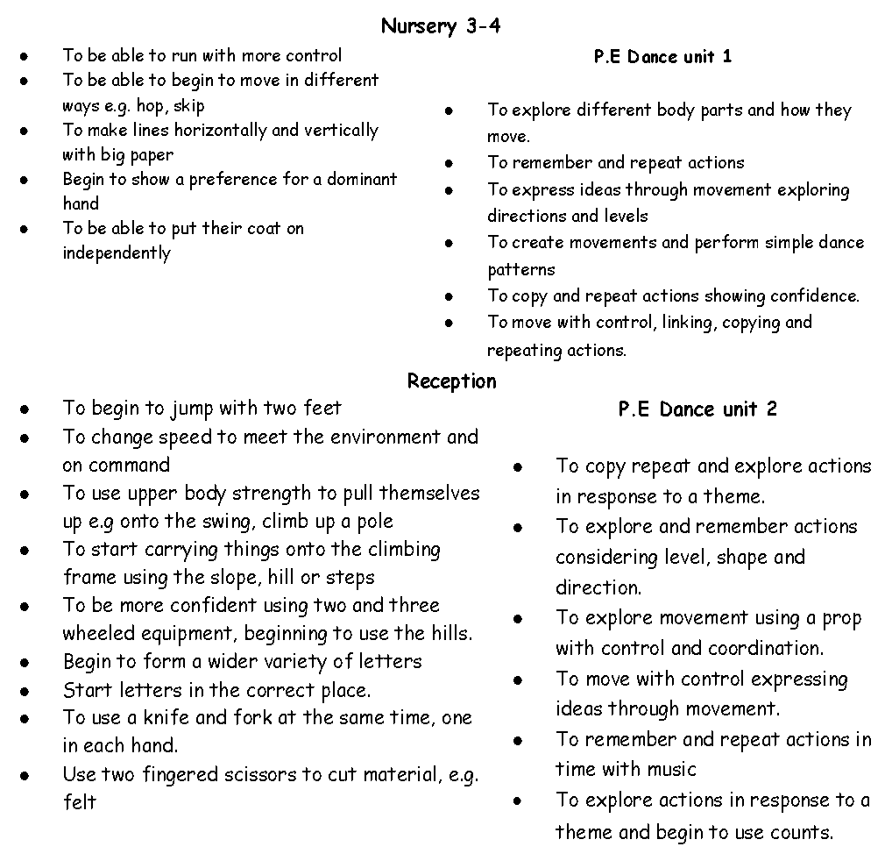

Nursery 3-4

To start teaching the concept of number
To subitise 1-3 in an irregular pattern.
Children to be able to choose their favourite number song.
To begin to understand the properties of 2D and 3D shapes. Begin to name them
Subitise a dice 1-6 to play a board game

Reception
To understand the concept of 0
To subitise and represent 0-5
To fond 1 more 1 less
To compare and explore mass and capacity
To find a balance
To find and represent 4, 5, and 6
To find pairs
To double to 8
To combine two groups
Explore and compare length

Nursery 3-4

Begin to look at a variety of different celebrations.
Look at the differences between school and home
Experience different parts of the school
Start to compare weather day to day
To begin to recognise significant times in their school day e.g. carpet, tooth brushing.
To learn about changing states e.g. snow, ice, noodles.

Reception
Look at and compare all different celebrations
Learn about features in our local environment e.g. local shops
Look at changing weather e.g. frost/snow/ ice

Nursery 3-4

To start to look at the pictures for set 1 cards.
To start to spot and suggest rhymes.
To make marks on their picture to stand for their name.
To engage in conversations about stories e.g. To predict what comes next in a simple patterned story
Reception

To segment and blend CVC words confidently
Begin to apply set 1 sounds in their writing
To write more independently within the provision.
To write short phrases with support
To use the pictures to retell a familiar story
Nursery 3-4

To start suggesting ideas at carpet time and in small groups
Looking after the classroom, tidying up during in tidy up times.
Begin to recognise classroom rules
To say hello to unfamiliar adults in the safety of their setting.
Spend extended periods of time without checking in with an adult (unless to ask for help)
Reception

To start to think of different strategies to overcome problems
Begin to use strategies to help them change the way they are feeling. e.g. count to 10, deep breaths, talk to a different friend.
To manage personal belongings and moderate when they are needed. E.g. begin to take top off when hot, if raining put a coat and hood on.
To understand that exercise is needed for a healthy lifestyle.
To begin the importance of being safe on the internet and a sensible amount of screen time.
To follow the rules with no reminders.
To start to recognise different feelings in others.

Nursery 3-4
To join in with the simple refrain in a story.
To understand and respond to questions e.g. what, where
To speak in sentences with at least 4 key words
To express an opinion using yes or no with adult
To give full attention during group time.

Reception

Begin to use because in short sentences
To begin to make links between books.
Begin to give reasons why you have chosen something.
To confidentially create a narrative in their play with friends.
Confidentially use comparative language.
To begin to explain to others how they can overcome a problem.
To begin to ask questions to clarify their thinking.
To be able to show that they can listen and respond to others ideas.

Spring 1 Celebrations and Monsters

Expressive Art & Design
Understanding the World
Mathematics
Literacy
Communication & Language
Personal, Social & Emotional

Nursery 3-4

To draw more complex images that represent their ideas.
To explore colour mixing
To sing songs independently as part of their play
Creating and making independently using narratives set out by the teacher

Reception

Kandinsky -artist study, colour mixing and shapes.
To cut out nets to make a cube
To begin to create their own poems and rhymes
To create their own songs to a familiar tune
Confidently give opinions on performance expressing why they do / do not like something and how it made them feel.

